**Galaxy Deffenders**

*Game Design Document*

IT 13 0646 00

K. A. S. H. Kodithuwakku

*Game Design*

**Summary**

Player is the Sri Lankan Air force pilot he tries to eliminate LTTE fighter planes and rescue the country.

**Gameplay**

The goal of the game is freedom. Obstacles are LTTE fighter planes

**Mindset**

Player is aggressive, powerful, nervous and hurried.

*Technical*

**Screens**

1. Title Screen

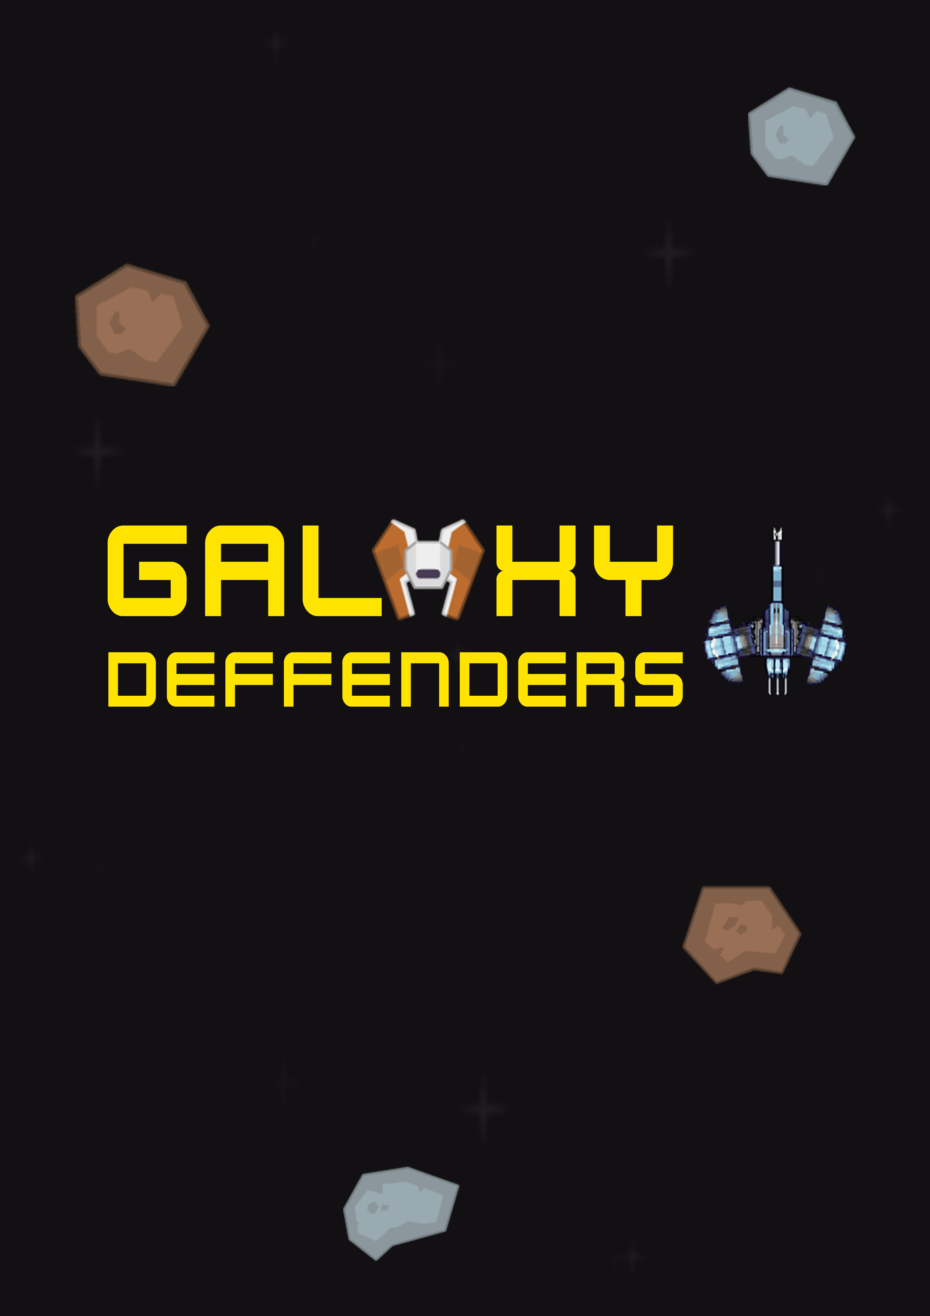

1. Main Menu

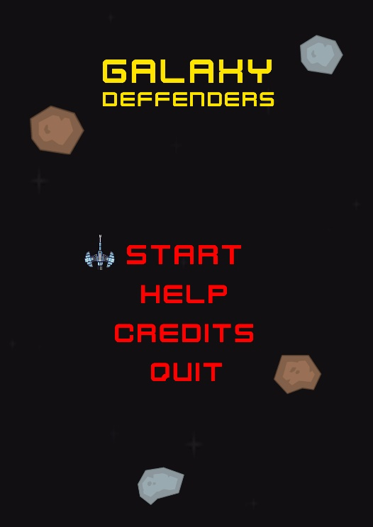

1. Game Play – Firing at enemies, collecting ammunition & medic pack

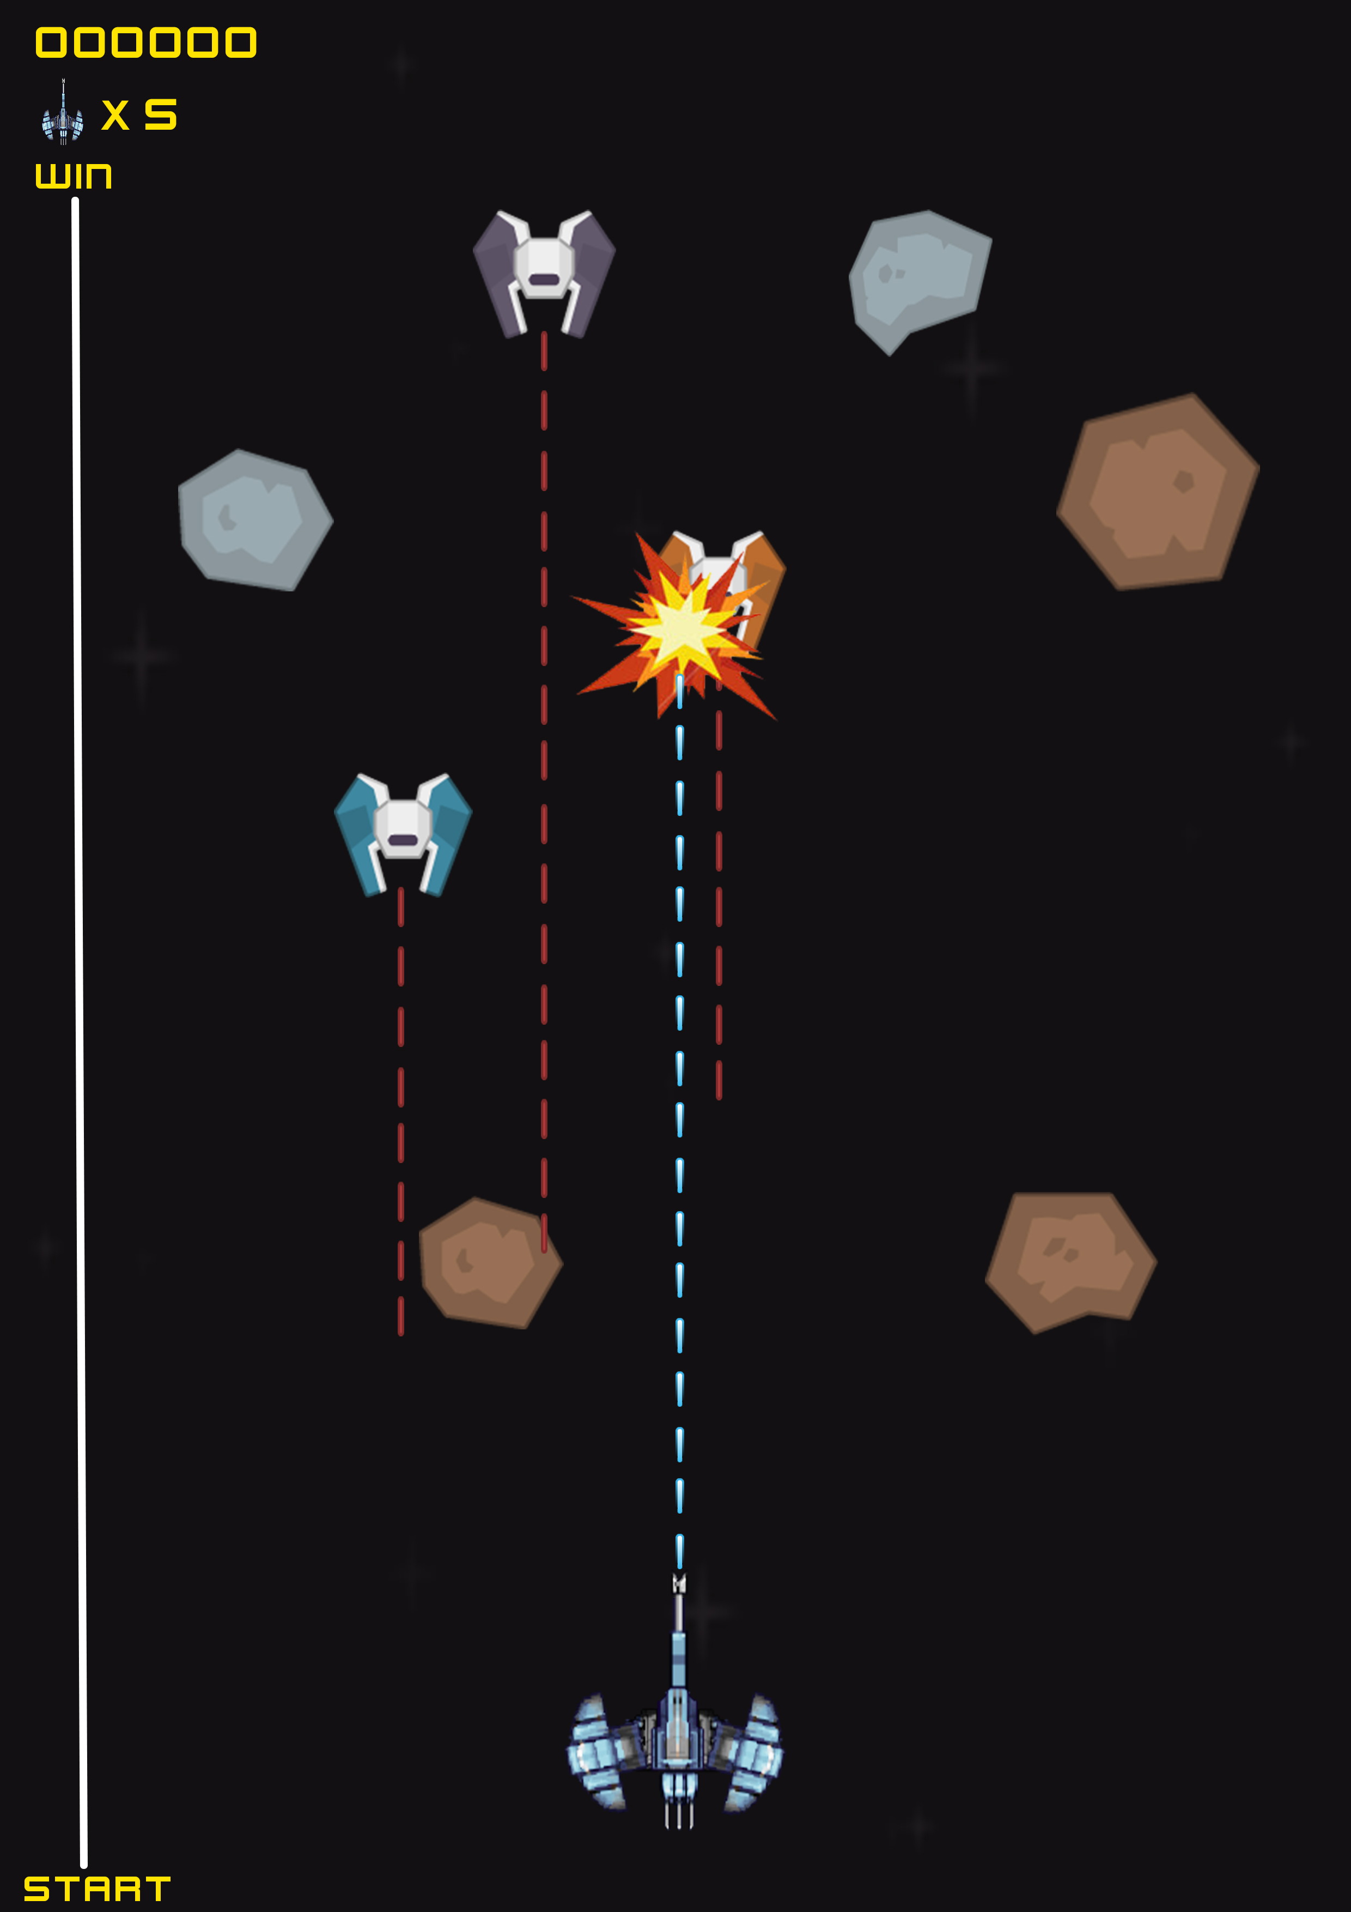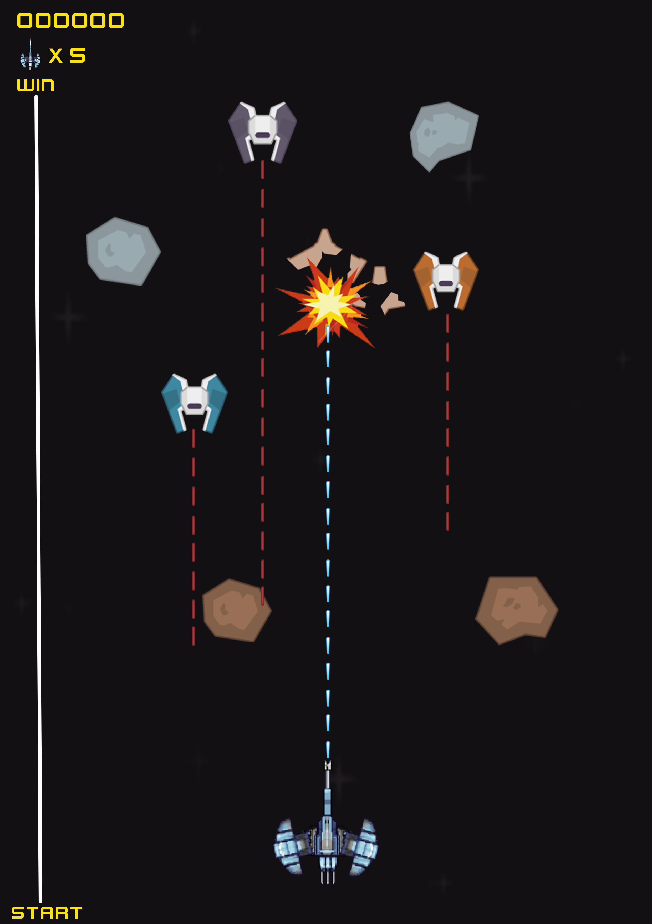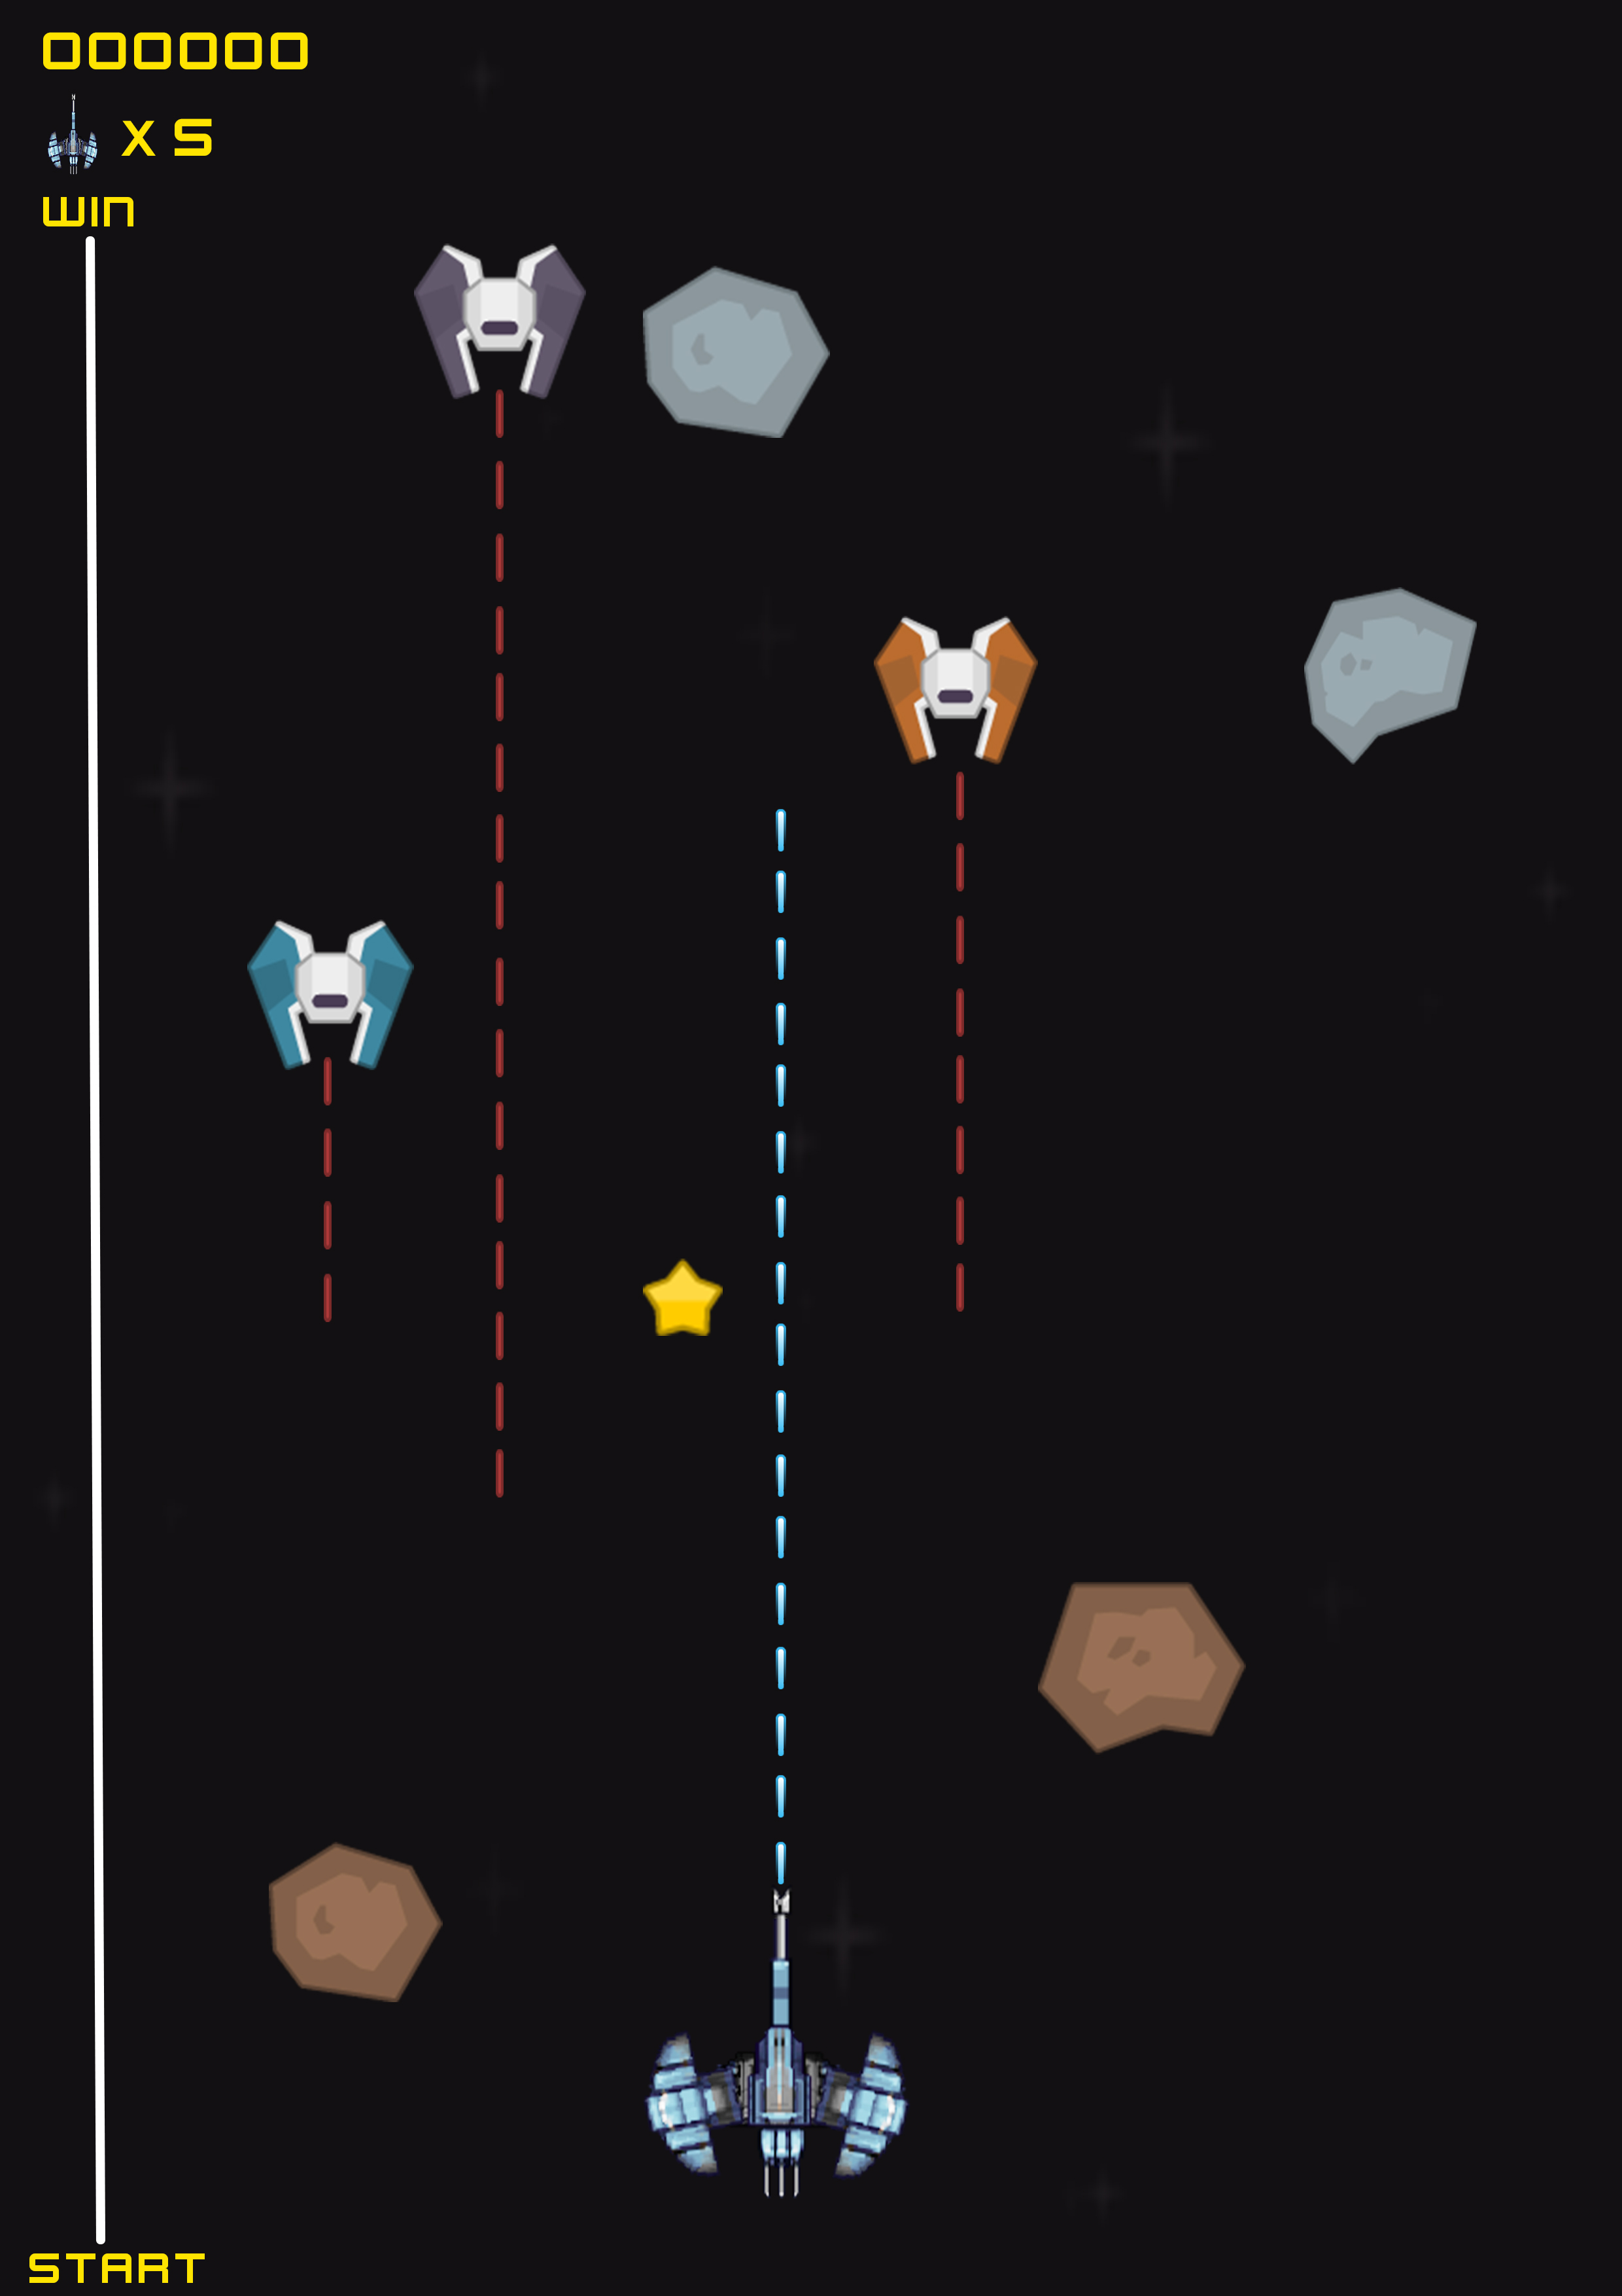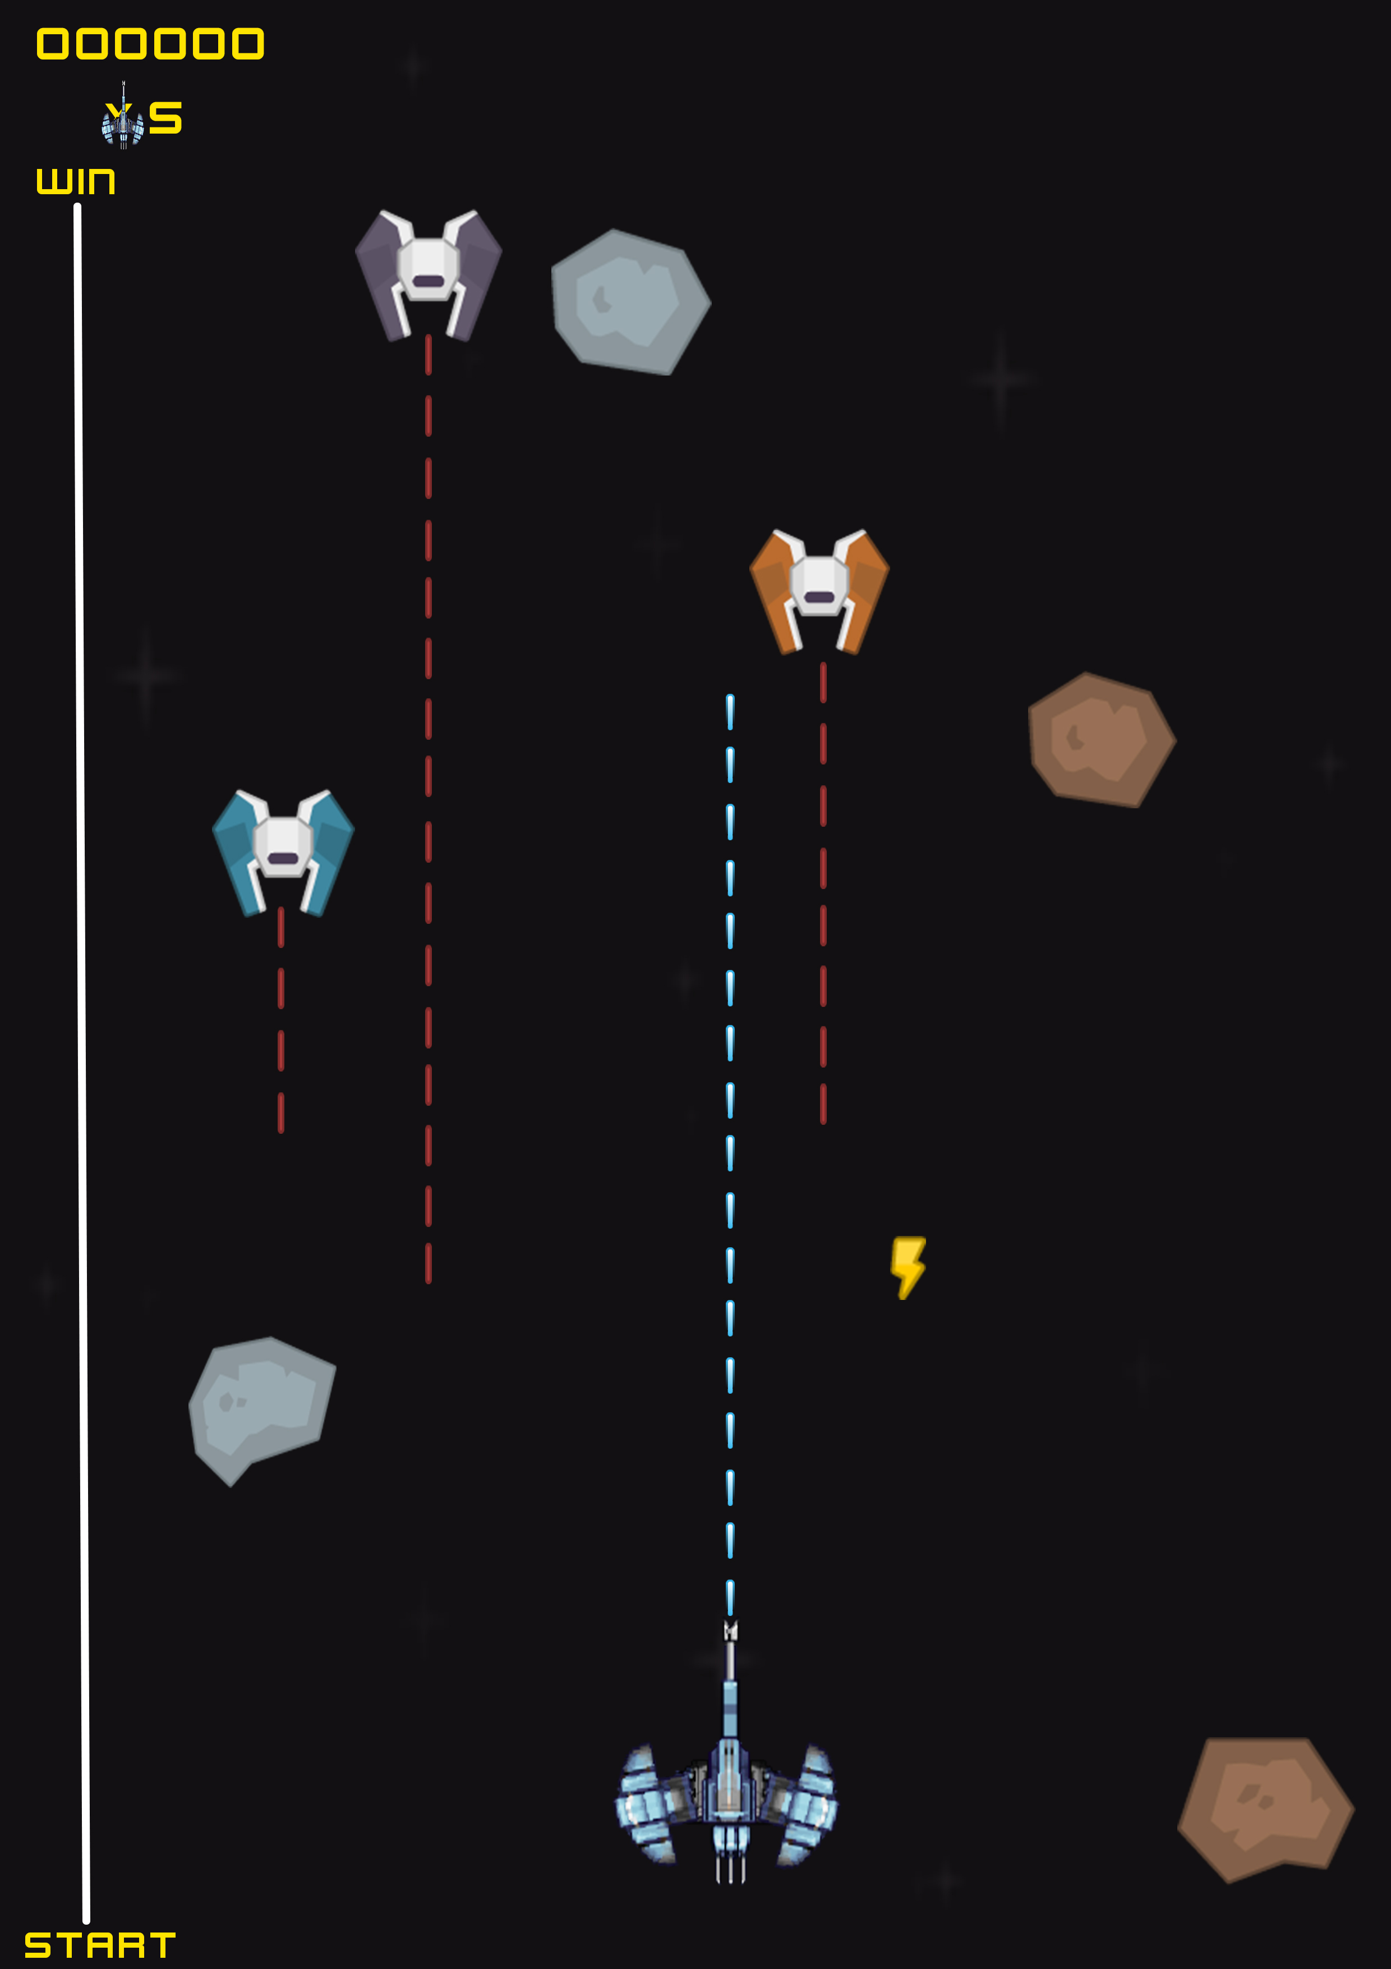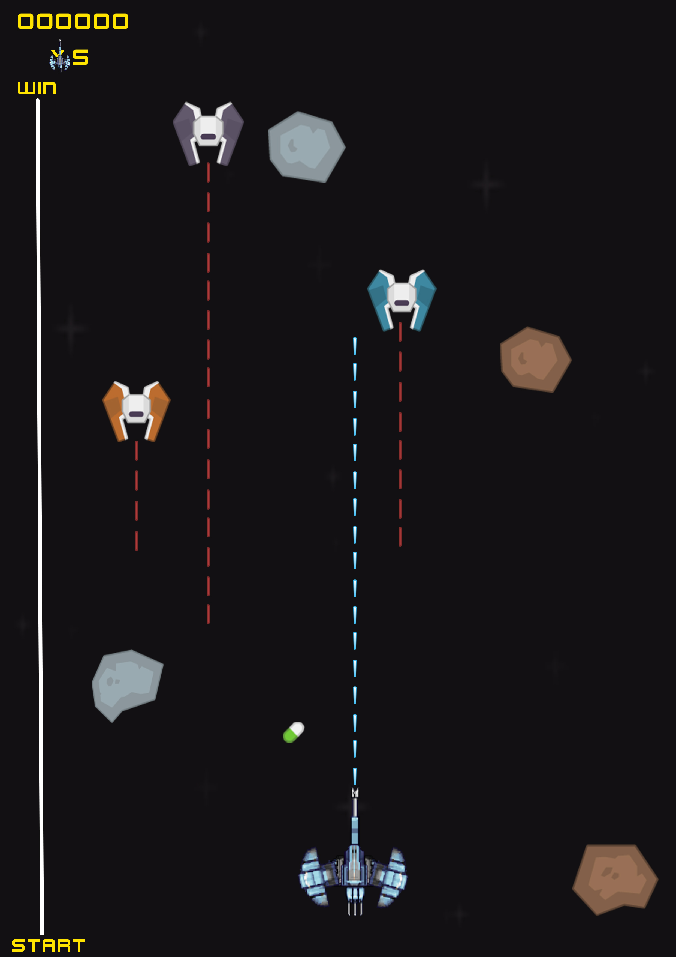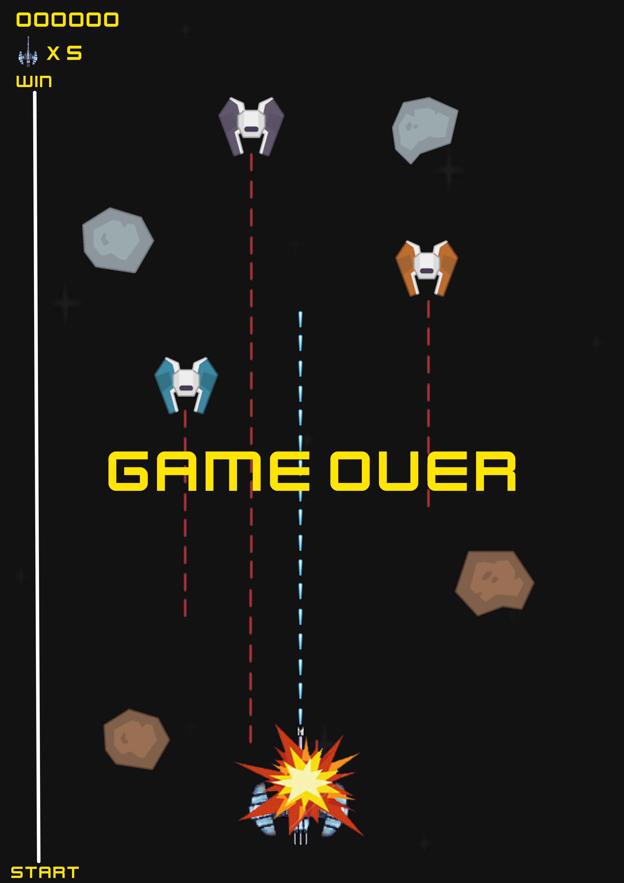

**Controls**

Controls will be touch screen left and right side clicking or tilting and tap to fire

**Mechanics**

-

*Level Design*

**Game Flow**

1. Player starts in random map
2. Enemy Planes are headed to our way firing at us
3. Player has to fire at enemy ships while touching screen
4. Player has to tilt screen left and right to avoid enemy shoots
5. Player can collect Health Pill, Bonus Points and Power Ups at random places
6. If player lost his 5 lives, Game will be over and shows his score.

*Graphics*

**Style Attributes**

In this game we use cartoony graphic style with Non-black outlines with limited tints/shades and uses smooth curvatures over sharp angles

**Graphics Needed**

1. Characters
   1. Players Plane
   2. Enemy’s Planes
2. Blocks
3. Space Rocks
4. stars

*Sounds/Music*

**Sounds Needed**

1. Effects
   * 1. Enemy Firing
     2. Player Firing
     3. Exploding’s
     4. Health Pill Collecting
     5. Bonus Point Collecting
     6. Power Ups Collecting

**Music Needed**

1. Clearside - Siste Viator
2. Clearside - Assimilator
3. Clearside - Below The Shift
4. Clearside - Coma

*Schedule*

* 1. Design Player ship
  2. Design Enemy ship
  3. Design Backgrounds
  4. Design Levels
  5. Design Main menu
  6. Loading game
  7. Starting Music
  8. Music disabling button
  9. Settings menu
  10. Level generating/selecting
  11. Power ups generating
  12. Power ups collection ( Collison )
  13. Distance calculation for one slide (small bar)
  14. Firing enemy ship situation
  15. Design Explosives
  16. Exploding enemy ship situation
  17. Getting hit by enemy ship (face to face)
  18. Collisions with treasures
  19. Time Calculating
  20. Score Calculating
  21. Life (health) leveling
  22. Collision with enemies
  23. Different firing modes
  24. Time up situations
  25. Health low situations
  26. Medic Pack Collecting
  27. Destination success full situation
  28. Level Play again button
  29. Next level loading
  30. Moving plane with finger
  31. game over situation
  32. Displaying Score board
  33. Game play sounds. (Firing, power ups, level complete, collision etc.)
  34. Game pause button
  35. Selection of Plane – Player can select a plane he or she likes